# Introduction

Choose your class and dive right into the heart of the action, armed with a potent array of cards. Unleash your units on the battlefield and watch them break through the enemy lines, making the battlefield your own. Feel the power as you wield game-changing spells that can turn the tide of battle. They are your weapons, your shields, your last-ditch efforts and your cunning tricks. They can outsmart your opponent, tilt the scales, and reshape the battlefield.

As the battle unfolds, your hero gains experience. Level up, and use these newfound strengths to change and adapt. Each point is a step closer to unlocking more potent powers, shaping your strategy, and asserting your dominance.

The game grows with you. Watch as your resources become more than mere numbers. They're the lifeblood of your strategy. Manage them well, and the battlefield will bend to your will.

It's a battle of strategic wits. Every action counts, even the smallest decision matters. Master your class, control your resources, and seize the battlefield. This is not just a game, it's a challenge of your strategy and skill. The question remains: are you ready to take command?

Table of Contents

Introduction 1

Gameplay and Goal 2

Components 2

The Battleground 3

Range 3

Setup 4

Player Turn 5

Mana Orb phase 5

Enchantments phase 6

First Main phase 6

Battle phase 7

Second Main phase 8

Mechanics 9

Summoning 9

Experience, Levels and Power tokens 11

Auras 12

Enchantments 12

Conditions 13

Keywords 13

Index (TODO generate) 14

# Gameplay and Goal

In this game, players begin with a hand of class-specific unit and spell cards. Units are summoned onto the battlefield, where they advance and engage in combat against enemy forces. Spells, offer a range of offensive and defensive maneuvers. They can be prepared, charged, and cast to influence the course of the battle. Both of these actions consume different types of mana orbs, the players' resources. These orbs must be carefully managed to effectively summon units and cast spells.

As the game progresses, players gain experience and level up, gaining power tokens which can be allocated on their class-specific power board. This development unlocks and enhances powers, shaping your strategy and strengthening your position. It's crucial to adapt and evolve, developing your class to maintain pace and ideally outperform the enemy player.

The ultimate objective is to use your tools and all the information you have to bring the enemy player life points to zero.

# Components

1. Cards
   * Paladin set (9 spells, 4x2 units, 4x2 unit upgrades)
   * Warlock set (9 spells, 9 spell upgrades, 5x2 units, 2x2 unit upgrades)
   * Elementalist set (10 spells)
2. Class Power boards
   * Paladin
   * Warlock
   * Elementalist
3. Condition tokens (Haste, Stun, Disarm, Turnover, Chill, Antimagic, Snare)
4. Mana tokens (white, red, purple, blue, summoning)
5. HP/Attack Dice
6. Life and Experience trackers
7. Power tokens
8. Enchantment tokens (for each player color, different shapes)

# The Battleground

The place where most things happen, the battleground is the focus of the game.

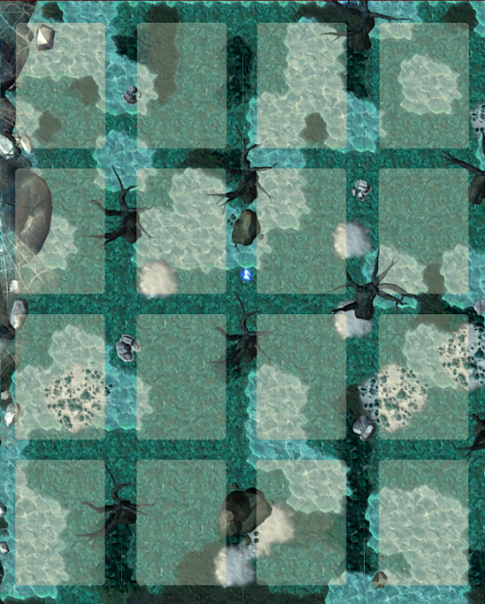

**1**

**3**

**4**

**5**

**6**

**2**

1 – **Field** – It can contain only one unit.

2 – **Intersection** – Where corners of two or more fields meet. Not a field.

3 – **Lane** – A chain of fields connected by their shorter edge (vertical).

4 – **Row** – A chain of fields connected by their longer edge (horizontal).

5 – **Adjacent** – Two fields are adjacent only if they share an edge. Two entities are adjacent if their fields are adjacent. Player heroes are never considered adjacent.

6 – **Neighbouring** – Two fields are neighboring if they share an edge or a corner. Two entities are neighboring if their fields are neighboring.

## Range

The range is counted by adjacent fields, orthogonally. Depending on the origin, the range is counted differently.

* When the origin is an **intersection**, all fields whose corners are part of that intersection count as being at range 1.
* When the origin is a **field**, only its adjacent fields count as being at range 1.

After you determine the fields at range 1, just keep counting adjacent fields. Examples below.

Field

Intersection

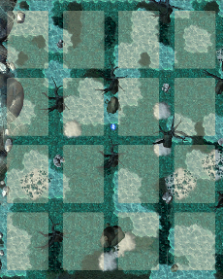

**1**

**1**

**1**

**1**

Range 1

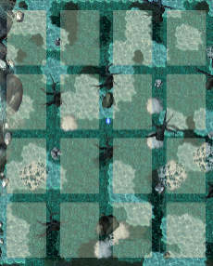

**1**

**1**

**1**

**1**

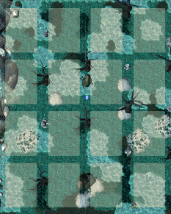

**1**

**1**

**1**

**1**

**2**

**2**

**2**

**2**

**2**

**2**

Range 2

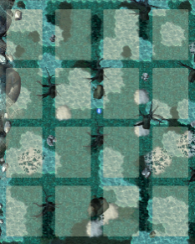

**1**

**1**

**1**

**1**

**2**

**2**

**2**

**2**

**2**

**2**

**2**

**2**

# Setup

The setup consists of 4 steps.

1. Decide the player order by rolling dice.
2. Set up exp tracker and life points tracker (20 life) for each player
3. Each player takes enchantment tokens of their color
4. Each player chooses a class (in player order), takes its class board
   1. Perform Start instructions according to the class board at the bottom (starting cards and Mana orbs etc)

Then organize your play area, and set your life points to the starting amount (20).

1. Available cards (hands)
2. Class Power boards
3. Spell preparation slots
4. Enchantment token piles
5. Mana Orb Pool/tracker
6. Experience trackers
7. HP and Attack dice pile
8. Mana token piles
9. Condition piles
10. Life Point trackers

# Player Turn

The turn consists of 5 phases.

Mana Orb phase 5

Enchantments phase 6

First Main phase 6

Casting a spell 6

Preparing a spell 6

Charging a spell 6

Battle phase 7

Performing an action 7

Attack action 7

Advance action 8

Defend action 8

Second Main phase 8

## Mana Orb phase

Mana Orbs produce mana that player can spend. Consuming a Mana Orb places it on the current step of the Mana Orb track.

During Mana Orb phase, advance your mana orb cooldown tracker to the next step. If the tracker moves onto a step that contains previously consumed Mana Orbs, they are refreshed, and immediately available for consumption.

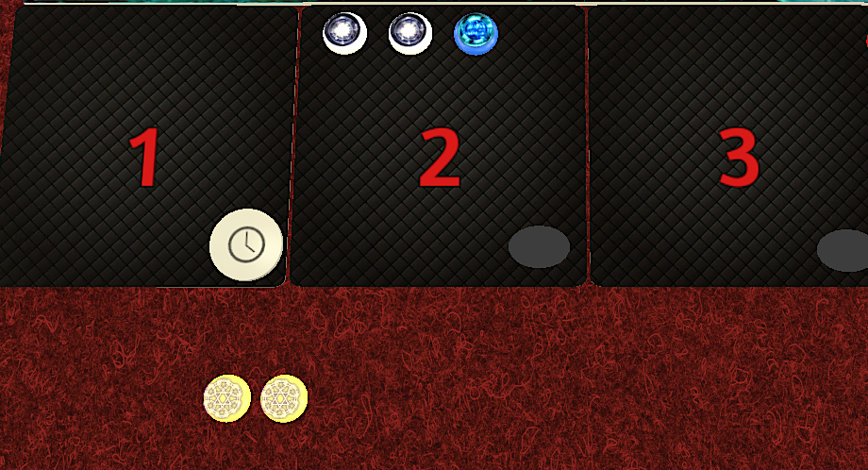

**1**



**2**

**3**

1. Mana orb cooldown tracker is moving at the start of player's turn
2. Player will refresh two white orbs and blue and they will join his available „Mana Orb pool“
3. Available mana orbs, currently two summoning orbs

## Enchantments phase

Read and resolve the "Enchantment" clauses on all owned cards in your play area and on the battleground which contain enchantment token of your color, in any order. Then remove one enchantment token from resolved enchantment. If the card was in your play area and the removed enchantment token was the last one remaining on that card, discard that card. Read more about enchantments on section Enchantments on page 13.

## First Main phase

Cards. Spells can be **cast**, **prepared,** and **charged**.

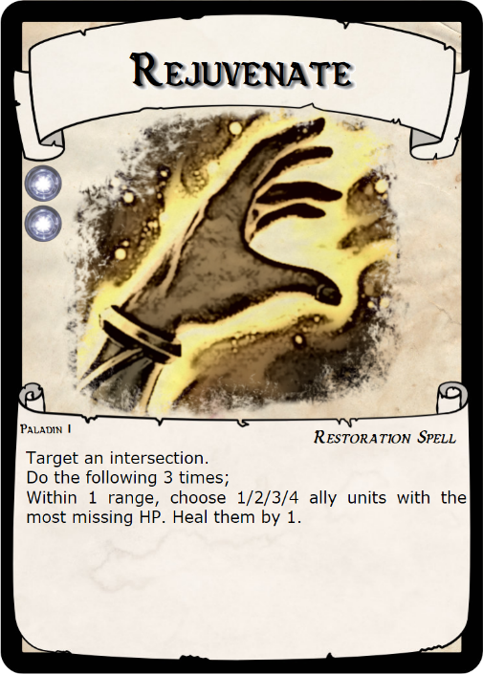

**1**

**2**

**3**

**4**

Image 2

1 – Name - of the card

2 – Cost - of the spell. The example is showing two white mana

3 – Type - of the card. These are used for interactions.

4 – Text – of the card. It is resolved upon casting the spell.

### Casting a spell

You can only cast a spell that is either prepared or in your hand. To do so, you must first pay its cost *[2, Image 2]* in mana. You cannot cast a spell if you cannot pay its cost. Then, place that spell in your play area and resolve its text. If it tells you to *summon* it, proceed to do so (How to summon“ on page 10). If its text creates an *Aura* or *Enchantment*, leave it in your play area and follow specific rules (Auras on page 11, Enchantments on page 13). Spells that were cast remain in your play area until the end of your turn and you cannot cast them again without a special effect.

### Preparing a spell

If you do not have the resources to cast the spell, or the situation does not call for it yet but you want something to use your mana orbs on, you may prepare a spell by placing it face down in your play area. You can only prepare a spell if you have a free spell slot (each player has 2 spell slots), however, you may replace an already prepared spell with a new one, discarding the old one in the process.

### Charging a spell

During your Main phase, you may use mana (gained from orbs or otherwise) to charge one of your prepared spells. Place the mana token on top of your prepared spell, it becomes a mana charge instead, and is not considered to be a mana token anymore. Each mana charge on a prepared spell counts as payment for when you would cast that spell. Mana charges cannot be removed and they are discarded if that prepared spell is removed. You cannot perform „Charging a spell“ if it would not reduce the cost of the spell. I.e. you cannot place 1 red charge or 3 white charge on a spell that costs 2 white mana. This allows your opponent a chance to guess which spell is prepared based on its mana cost. You can still place charges that do not reduce the cost using other effects.

**Fully charged spell can be cast in every player phase except the Battle phase, including the enemy turn.**

## Battle phase

This is a phase where units on the battlefield act. Units perform actions **Advance**, **Attack**, or **Defend**. Units perform actions in two waves.

All units act -> All units act -> Gain 1 Exp

### Performing an action

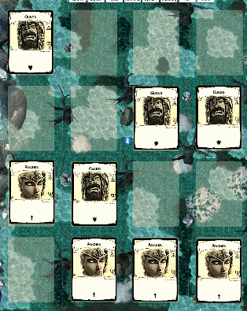

**1**

**2**

**3**

**4**

**5**

**6**

**7**

**8**

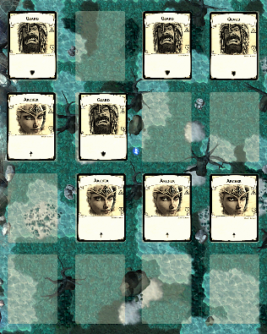

**1**

**2**

**3**

**4**

**5**

**6**

**7**

**8**

Units perform an action row by row, left to right. Following combinations are allowed for each unit:

1. Attack -> Advance
2. Defend -> Advance
3. Advance -> Attack
4. Advance -> Defend

### Attack action

When a unit performs an Attack action, it is resolved through the following steps.

1. Determine a target – Search for a **foe** in a clockwise direction (left to right), prioritizing foes that are lower range from the attacker. In the example, Guard attacks #2

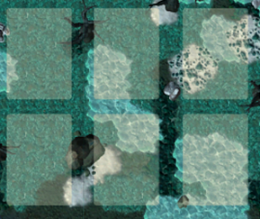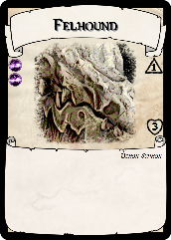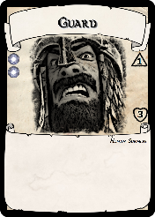

**1**

**2**

**3**

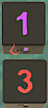

Image 3

1. If there is no available target, the unit does not execute the attack.
2. If the attacker has a valid target, it executes the attack. Deal damage by subtracting the attacker's „Attack“ value (purple die) from the defender's „HP“ value (red die), reduced by defense value (more on Defend).
3. After the attack action, if the attacked unit's HP is equal or less than 0, it dies.

#### Damaging enemy Heroes

Player heroes count as a valid attack target. When a unit performs an attack action against the far edge of its lane, this attack is executed against heroes on that side of the battlefield. Perform damage calculation for each player hero separately. On the image, both Archer (with range 2) and Guard are attacking enemy player.

#### Unit Death

After a unit dies, in Battle phase, due to suffering damage, spell effect or in other ways, it is discarded. Owner takes the card into their hand. Check for kill credit and award experience.

Owner of the attacking unit that has dealt the killing blow gains 1 exp, but only if the attacked unit is owned by the enemy player (auto-kills or denials do not reward exp).

### Advance action

Units cannot change lanes. When a unit would advance, first, check if the unit has a valid attack target. If such is the case, end the advance action.

If unit has no valid target to attack, first check if the field in front of the unit is occupied. If it's not occupied, execute the Advance action by moving the unit onto that field.

### Defend action

When a unit performs Defend action, rotate the card sideways. It is considered to be „defending“ until its first action during its next Battle phase. When a unit that is defending would be attacked, its defense value is subtracted from the attacker's Attack value before applying the damage. If defense value is below 0, it is not applied.

Base defense value is equal to 1. Each showing on the unit adds 1 defense value.

Defense value can also be reduced. A unit is considered to threaten a foe if following conditions are met:

* The unit is adjacent to its foe
* The unit has an attack value (which means it is able to perform an attack)
* The unit is not defending
* The unit is not the attacker for this check

A unit that is being attacked is considered to be in a flank if there is at least one unit that threatens it. A unit in flank loses 1 defense value for every unit that threatens it.

## Second Main phase

This phase is identical to the first main phase. Read more on page 7.

At the end of second Main phase, take every card that is in your play area and contains no enchantment tokens (so, skipping prepared spells and cards with active enchantments) back into your hand.

# Mechanics

## Summoning

When a card text or a power tells you to „summon“ a card, it must be placed onto the battleground.

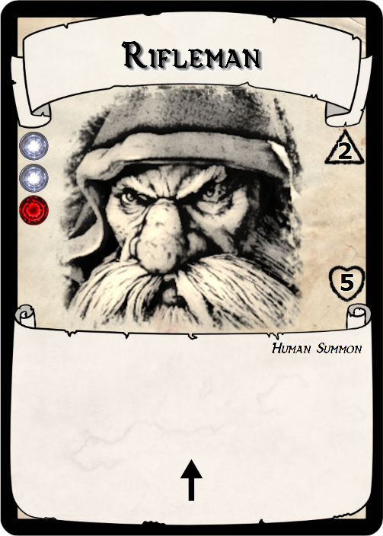

**1**

**2**

**3**

**4**

**5**

**6**

1 – Name - of the card

2 – Type - of the card. These are used for interactions.

3 – Text – of the card. May contain auras or enchantments.

4 – Attributes – Example unit has 1 additional attack range.

5 – Base Attack – value of the unit.

6 – Base HP – of the unit.

### How to summon

You place the card onto the battlefield. If the effect does not specify how, do it in one of the empty fields in the row closest to you. Then you place an Attack die and set it to the unit's base attack value, and place an HP die and set it to the unit's base HP value. Do not this if the card has no base Attack or HP value.

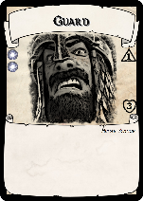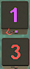

In this example, Guard has a base attack value of 1 and a base HP value of 3.

**Every summoned card is considered a „unit“.**

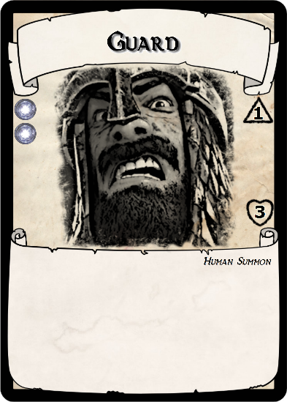

### Unit Modifiers

Modifiers add special abilities to the unit. Each modifier changes the way it acts during battle phase or it adds additional bonuses to actions it already has.

Attack range – When a unit would attack, include targets at +1 range from the attacker. Base attack range is 1, and each Range modifier showing increases the attack range by 1.

Shield – For each shield modifier showing on a unit, add +1 to its Defense value when it is defending.

Pack Tactics – A unit with Pack Tactics showing threatens even while it is defending.

Grounded – A unit with Grounded stays within its field during all of its Advance actions.

## Experience, Levels and Power tokens

To strengthen and develop your toolset with new units or spells, gain new mana orbs and unlock new powers, you need power tokens. You gain a power token every time you level up, after you collect 3 experience. You can gain an experience point in several different ways.

* 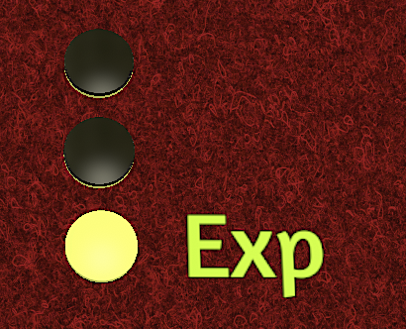At the end of your Battle phase, you gain 1 exp.
* After you kill a unit that is owned by your opponent, you gain 1 exp.
* After you summon a card, you gain 1 exp.

After reaching 3 exp, reset them and gain a power token and choose where to place it on your class board.

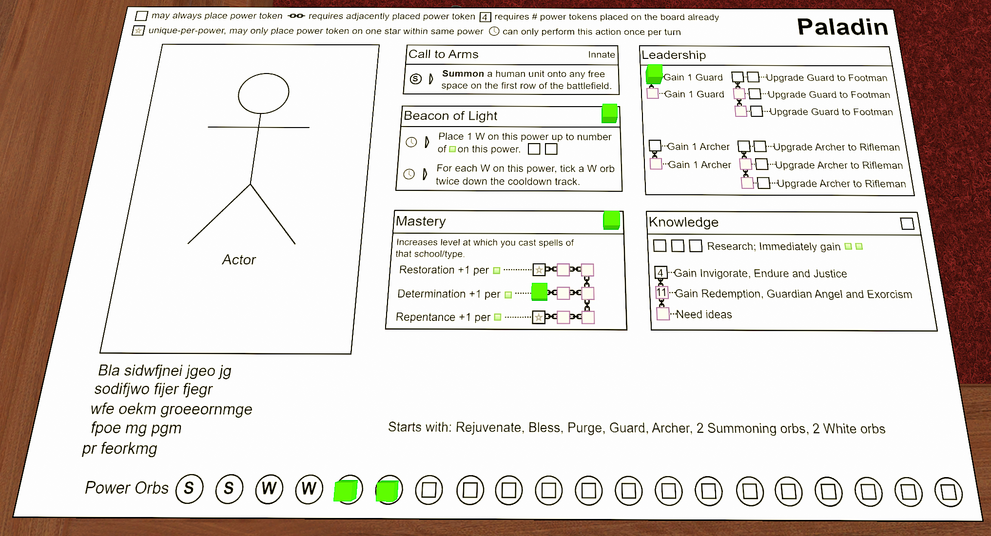

## Auras

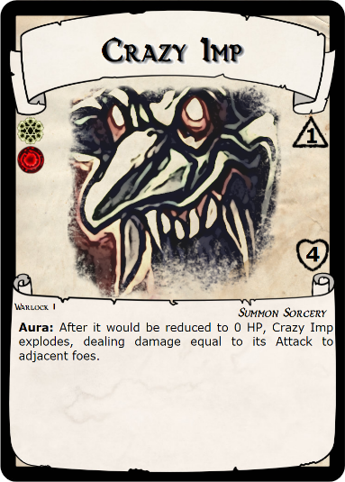

Some cards have an „Aura“ clause in their text. It is a persistent ongoing rule that is always active for as long as the card is in play, and whose effect usually depends on some condition or situation.

When a spell that you cast creates an Aura, it remains in your play area until it is explicitly removed.

If a summoned unit has an Aura, it is active for as long as that unit is on the battleground.

## Enchantments

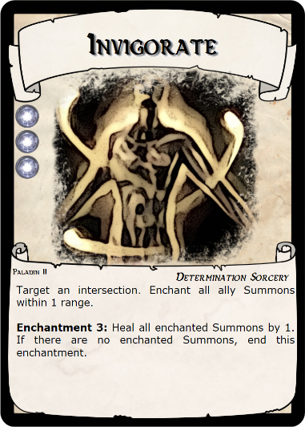

**1**

**2**



**3**

Some spells create an „Enchantment“ while resolving its text (2). Enchantments are resolved during the “Enchantments” phase of the owner’s turn.

***Enchantment tokens*** (3) – are used to establish a relationship from an active Enchantment to the units that it affects.

When you cast a spell that creates an Enchantment, choose an enchantment token shape that isn’t already in play (3) and place it on that card.

***Duration*** – If the spell text has a number next to the “Enchantment” keyword, it means the enchantment has a duration. It will only resolve that amount of times, and then it will be discarded. When this Enchantment enters play, it starts with a number of enchantment tokens equal to this number. At the end of every player’s “Resolve Enchantments” phase, the player removes one enchantment token from all of his enchantments in play.

***Ending an enchantment*** – An enchantment ends after the last enchantment token of matching shape is removed (from its card). Remove all matching enchantment tokens from the battleground and play area. If the card was in a player’s play area and it has no more active enchantments, discard the card immediately (owner of this card takes it into their hand).

## Conditions

Some spells apply one or more conditions to their targets. Each condition has its own rules, no matter what applied them or when they were applied.

### Haste

Each haste token causes a unit to perform an additional Advance or Attack at the end of its next Battle phase.

### Stun

Causes a unit to skip both actions in its next Battle phase. After skipping its second action, discard all its Stun tokens.

### Disarm

When a unit with Disarm would execute an Attack, it does not. Instead, it discards all Disarm tokens.

### Chill

When a unit with Chill tokens deals damage with an Attack, reduce damage taken by 1 for each Chill token it has, then discard a number of Chill tokens equal to damage reduced (any extra Chill tokens remain on that unit).

### Turnover

A unit with a Turnover is considered a foe to its owner and an ally to its owner’s opponents. When performing Advance action, it moves towards its owner. Its owner does not change, only its behavior is changed.

### Antimagic

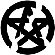A unit with Antimagic cannot be targeted or enchanted by cards, any damage dealt by Spells becomes 0 and cannot be modified. Spells that are cast cannot place any conditions onto them. Antimagic is discarded during that unit’s owner’s next Enchantments phase.

### Snare

A unit with Snare skips its next Advance that it would execute, then discards one Snare token.

# Keywords

***Discard (a card)*** – Owner of the card takes it into their hand immediately.

***To attack*** – perform an attack as specified in the section “Attack action” on page 7.

***To defend*** – rotate the unit sideways. Attacks against it are reduced by its defense value base 1.

***To heal*** – A unit that is healed gains the listed amount of HP, but only up to its base HP. Healing a unit that has equal or more HP than its base HP value has no effect.

***To enchant*** – Place a new enchantment token on the entity that is being enchanted, matching the enchantment's token shape. Only place one token, unless specified otherwise.

***To unenchant*** – Remove all enchantment tokens matching this enchantment's token shape from the specified entity.

***enchanted (conditional)*** – Whether the entity in question has one or more enchantment tokens matching the enchantment token shape of that enchantment.

***To end (an enchantment)*** – Remove all enchantment tokens, with matching shape, from the card.

***To summon*** – To summon a card as specified in the section „How to summon“ on page 9.

***To target*** – Choose a target entity. The following text will refer to this entity.

***Gain (mana)*** – Take a mana token of the listed color. You can spend it until the end of this turn.

***Gain (Attack or HP)*** – Increase the value on the appropriate die without limit. If necessary, add more dice.

***Deal damage (to a unit)*** – Reduce its HP die by the listed amount. If unable to do so, that unit is killed.

***Dies (a unit)*** – A unit dies when its HP would be reduced below 1 HP. It is discarded.

***Alive (a unit)*** – a unit is alive as long as it's on the battleground and has 1 or more HP.

***HP*** – A unit's current HP value, sum of values shown on its HP dice.

***Attack*** – A unit's current Attack value, sum of values shown on its Attack dice.

***Base HP*** – An HP value shown on the unit's card.

***Base Attack*** – An Attack value shown on the unit's card.

***Kill (a unit)*** – Reduce its HP to 0. Take credit for its death.

***Own/owned (a card)*** – A card is owned by a player that cast or summoned it.

# Index (TODO generate)